

Target System: Tawakkalna
Based on the EMAM Framework

Instructor: Prof. Adeeb Noor
Student Name: Talal Abid Alharbi
Student ID: 2236482
CPIT455

Contents
Part 1: افهم (Understand) - 20% 2
CIA Analysis & Threat Landscape 3
1. The Mission Context 3
2. CIA Triad Analysis (Islamic Integration) 3
3. Saudi Threat Landscape 3
Part 2: مارس (Practice) - 30% 4
STRIDE Analysis & Misuse Cases 4
1. STRIDE Threat Model (Tawakkalna Specific) 4
2. Misuse Case: The "Evil Twin" Identity Theft 4
Phase 3: اتقن (Master) - 30% 5
Design Guidelines & Secure Coding 5
1. Applying 10 Design Guidelines (Selected Key Implementations) 5
2. Secure Code Sample (Python/Flask Mockup) 5
Phase 4: ميز (Excel) - 20% 6
Testing Plan & Vision 2030 6
1. Security Testing Strategy 6
2. Vision 2030 & Innovation 6
Conclusion 6

Part 1: افهم (Understand) - 20%

CIA Analysis & Threat Landscape

1. The Mission Context
Tawakkalna has evolved from a COVID-19 permit app to a national "Super App" facilitating access to sensitive government services (Absher, Sehhaty, Ministry of Justice). It represents a massive Single Point of Failure for the digital life of a Saudi citizen.

2. CIA Triad Analysis (Islamic Integration)
We analyze the security goals through the lens of Maqasid al-Shariah (Objectives of Islamic Law):
- Confidentiality (السرية) - Hifz al-Ard (Protection of Honor/Privacy):
  - Requirement: Health data (vaccines, chronic diseases) and family records must be visible only to the authorized user.
  - Islamic Principle: "And do not spy" (Qur'an 49:12). Privacy is a divine right, not just a feature.
- Integrity (النزاهة) - Hifz al-Mal (Protection of Wealth/Rights):
  - Requirement: Digital deeds, licenses, and permits must be tamper-proof.
  - Islamic Principle: Prohibition of Tazwir (forgery). A fake status could unjustly grant or deny rights.
- Availability (التوافر) - Hifz al-Nafs (Protection of Life):
  - Requirement: The app must function 24/7, especially during Hajj or health emergencies.
  - Islamic Principle: Enabling public utility (Maslahah Mursalah). Downtime hinders essential services.

3. Saudi Threat Landscape
- APT Groups: State-sponsored actors targeting Saudi infrastructure (legacy of Shamoon).
- Insider Threats: Unhappy employees with access to the citizen database.
- Supply Chain Attacks: Compromised third-party libraries used in the app.

Part 2: مارس (Practice) - 30%

STRIDE Analysis & Misuse Cases

1. STRIDE Threat Model (Tawakkalna Specific)
Threat Category | Specific Threat to Tawakkalna | Mitigation Strategy
Spoofing | Attacker impersonates a user to access digital ID (Iqama/License). | Nafath (IAM) integration with biometric verification (Face/Fingerprint).
Tampering | Modifying the local database to show a "Green" health status or valid permit. | Digital Signatures on all status objects; server-side validation only.
Repudiation | A user denies requesting a permit or accessing sensitive records. | Immutable Audit Logs linked to National ID and timestamp (Blockchain).
Information Disclosure | Leaking family records via an insecure API endpoint (IDOR). | Strict ACLs (Access Control Lists) ensuring users view only their own dependents.
Denial of Service | Overwhelming the login API during peak times (e.g., Hajj entry). | Rate Limiting at the API Gateway; CDNs for static assets.
Elevation of Privilege | A standard user gaining admin rights to view other users' data. | Zero Trust Architecture; separate admin interfaces with VPN access only.

2. Misuse Case: The "Evil Twin" Identity Theft
- Normal Use Case: User logs in → Authenticates via Nafath → Views Digital ID.
- Misuse Case: Attacker clones app → Phishes OTP → Views Victim's ID → Opens bank account.
- Security Control: Implement Device Fingerprinting. If the device ID changes, force a fresh biometric challenge via the official Nafath app, not just an OTP.

Phase 3: اتقن (Master) - 30%

Design Guidelines & Secure Coding

1. Applying 10 Design Guidelines (Selected Key Implementations)
- Defense in Depth: Do not rely solely on the password. Layer: Password + Nafath Biometric + Device Binding + Geolocation Check.
- Fail Securely: If the backend is unreachable, the app should fail closed (show no data) rather than cached sensitive data without re-authentication.
- Least Privilege: The "Permits Service" should only have read access to the "Permits DB," not the "Health DB."

2. Secure Code Sample (Python/Flask Mockup)
This code demonstrates Input Validation, Authorization, and Audit Logging.
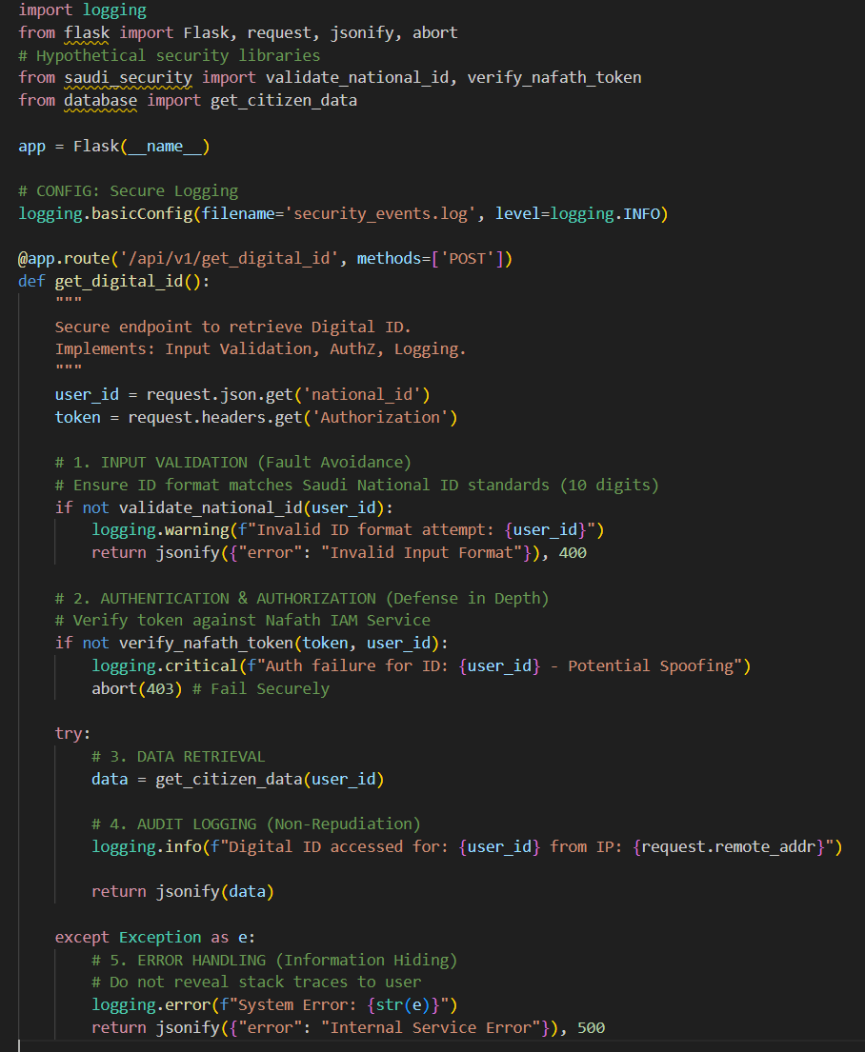

Phase 4: ميز (Excel) - 20%

Testing Plan & Vision 2030

1. Security Testing Strategy
- Static Application Security Testing (SAST): Run SonarQube daily on the CI/CD pipeline to catch hardcoded credentials or SQL injection risks.
- Dynamic Application Security Testing (DAST): Use OWASP ZAP to fuzz the API endpoints, simulating an external attacker trying to break authentication.
- Penetration Testing: Engage "White Hat" hackers via the SDAIA Bug Bounty Program to find logic flaws that automated tools miss.

2. Vision 2030 & Innovation
- The "Sovereign Cloud" Concept: Ensure all Tawakkalna data resides physically within KSA (e.g., NEOM tech centers or Alibaba Cloud Saudi) to prevent foreign jurisdictional access.
- AI-Driven Threat Detection: Implement an AI model that learns "normal" citizen behavior. If a user suddenly accesses their Digital ID from a foreign IP at 3 AM, the AI triggers a lockdown (Adaptive Authentication).

Conclusion
By applying the EMAM Framework, we have moved beyond treating security as a checklist of "firewalls" and "updates." Instead, we recognize Tawakkalna for what it truly is: a National Trust (Amanah) and the digital backbone of Saudi society.
Key Takeaways:
- Security as a Journey, Not a Destination: This assessment confirms that security requires continuous Itqan (Excellence). Threats evolve daily (e.g., AI-driven attacks), and our defenses must adapt just as fast through continuous monitoring and "Red Teaming."
- Digital Sovereignty: By keeping data within the Kingdom and using local encryption standards, we protect our nation's data from foreign interference, directly supporting the National Cybersecurity Authority (NCA) mandates.
- Trust is the Currency: In the digital economy, user trust is as valuable as oil. A secure Tawakkalna ensures that citizens confidently embrace the digital transformation envisioned in Vision 2030.

